

NCIA – National Cancer Imaging Archive

Software Design Description

Release 2.0 – Display Content Type


Document Change Record
Version Number | Date | Description
1.0 | 06/26/06 | Initial document

TABLE OF CONTENTS
1. Introduction 1
1.1 PROJECT BACKGROUND 1
1.2 SYSTEM OVERVIEW 1
1.3 Requirements Traceability 2
1.3.1 Relevant Statement of Work Tasks 2
2. Use Cases 3
2.1.1 New Use Cases 3
2.1.2 Changes to Existing Use Cases 3
2.1.3 Display Search Results Use Case 3
3. System Architecture 6
4. configuration 7
4.1 Add content type CDE concept code to NCIA.PROPERTIES 7
5. Sequence diagrams 8
5.1 drill down to view studies and series for a patient 8
6. Components 9
6.1 USER INTERFACE 9
6.1.1 Search Results (Studies for Subject) Page 9
6.1.2 Search Results (Images for Series) Page 9
6.1.3 Data Basket Page 10
6.1.4 OverlibTag class 10
6.2 User interface Backing Beans 11
6.2.1 SeriesDTO 11
6.3 MIDDLE TIER 11
6.3.1 SeriesContentTypeResultSet 11
6.3.2 StudiesForSubjectResultSet 11
6.3.3 DICOMPatientQueryHandler 12
6.3.4 ResultSetManager 12
6.4 UTILITIES 12
6.4.1 NCIAConfiguration 12
6.5 BACK END 13
6.5.1 Domain Classes 13
6.5.2 Database Design 13
6.5.3 Views 13
6.5.4 Indexes 13

Introduction
The purpose of this document is to describe the design for the Display Content Type feature being developed for Release 2.0 of the NCIA – National Cancer Imaging Archive software.
Currently, NCIA only displays whether or not annotation files have been associated to the series. This enhancement allows users to view the content types of annotation files that have been associated to a series if a content type has been provided.

PROJECT BACKGROUND
Please refer to the NCIA Architecture Overview for background on the NCIA project.

SYSTEM OVERVIEW
Please refer to the NCIA Architecture Overview for a system overview.
.

Requirements Traceability

Relevant Statement of Work Tasks
The NCIA Statement of Work (SOW) Task Description contains the following items that will be implemented as part of this design:
4.1.10 Extend UI to Show the Content Type of Annotation (Pathology, Clinical, Radiologist Review, etc.) That Is Associated with Images (3.2.2)
This effort involves the extension of the NCIA UI to display annotation content type (pathology, clinical, radiologist report) on the search results and data basket pages instead of simply indicating that the series has annotations.
▪ Assumptions:
o Content type will be provided by curator through curation spreadsheet
o Entering of data by the curator is not covered in this task
o Content type will be shown when content type data has been provided by curator

Use Cases
User preferences requirements were documented by a combination of adding new use cases and updating existing use cases.

New Use Cases
There are no new use cases for this enhancement.

Changes to Existing Use Cases
The changes relevant to this enhancement are highlighted in grey.

Display Search Results Use Case

Use Case Name | Display Search Results Use Case
Use Case ID | 10.1
Primary Actor | Researcher (via Simple/Advanced Search)
Secondary Actor | Image data store  Annotation Database
Trigger | System has successfully retrieved the user requested data for display
Pre-conditions | - The query is executed without any system errors.
Flow of Events | - The system has successfully retrieved the data requested by the user.  - The search results page includes a list of subjects sorted by Subject ID that have at least one visible series matching the criteria. For each subject, the results include:  - Subject ID  - Trial ID  - The number of studies and series for the patient that contain at least one visible image meeting the criteria.  - The total number of studies and series for the patient.  - A “Show Studies” link.  - The actor can click on the Show Studies link to “drill down” to the study level.  - The Search Results (Studies for Subject) page is displayed. It includes a list of all of the studies or the selected subject (sorted by study date) that contain at least one visible series matching the criteria. For each study, the following is displayed:  - Study ID  - Study Description  - Study Date  For each study, a list of series (ordered by series number) for the study that have been marked as visible matching the criteria is displayed. For each series, the following is displayed:  - Series ID  - Total Number of Images in the Series  - Note: This number includes both visible images that meet the criteria and those that don’t.  - Series Description  - Series Modality  - Series Equipment Manufacturer  - Whether or not annotations exist for the series. If curation data exists to describe the content type of the series’ annotation files, display all available content types.  - A “Show Images” Link  - The user clicks the “Show images” link to display the visible images in that series.  - The system displays a set of thumbnails for all the images in the series with a QA status of Visible sorted by the image date. (Thumbnails for visible images that do not match the criteria are displayed also). A summary of the series is also displayed that includes whether or not the user has annotations and the content types of the annotation files if there is available curation data to describe the content type.
Post-Conditions | Success Condition: User views the results.
Alternative Flow | - If no data is returned by executing the query, an appropriate message is returned to the search results page.  - On the subject's page, the user clicks on the icon in a column title to sort the list by the data in that column.  - User clicks a link to go back and view the search page. System executes use case 9.1. This option is not available if the search results were created by linking from another application (see use case 9.3).
Related Use Case | 11.4 Add to Data Basket Use Case

System Architecture

No changes are being made to the NCIA architecture for this enhancement.

configuration

Add content type CDE concept code to NCIA.PROPERTIES
Content type is stored as curation data (see Parse Curation Spreadsheet design). When the curator enters content type, he will identify the data as content type using a CDE concept code. This concept code will be stored in ncia.properties so that it is configurable. The property will be named contentTypeCdeConceptCode.

Sequence diagrams
For some use cases, sequence diagrams are helpful to illustrate the execution flow. Sequence diagrams are included this section for the appropriate use cases. Details of the objects that participate in the sequence diagram are described in section Error: Reference source not found.

drill down to view studies and series for a patient
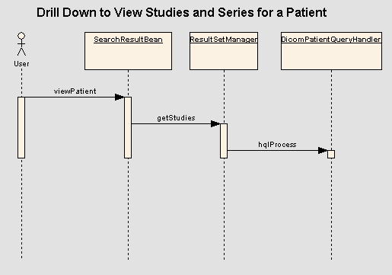

Components

USER INTERFACE

Search Results (Studies for Subject) Page
This page currently displays “Yes” or “No” in the “Contains Annotations?” column to indicate whether or not the series has annotation files associated with it. For this enhancement, “Yes” will become a link if the series has annotations and if any content types have been entered as curation data for the series’ annotations (SeriesDTO.hasContentTypes = true).
When the link is clicked or floated over, a small window will appear displaying the content type of the associated annotation files. The small window will be created using overlib, which is already used to create the small windows that appear when the help icons are clicked. The overlib will be implemented as described in section Error: Reference source not found. If there are multiple content types available, they will be displayed as a comma separated list.
Here are examples of the user interface changes:
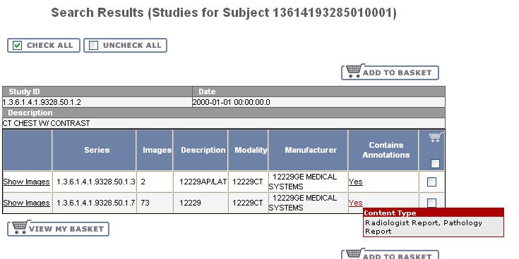

Search Results (Images for Series) Page
Instead of a pop-up window, the content type will be displayed under the “Annotations” heading. The heading will be changed from “Contains Annotations” to “Annotations”.
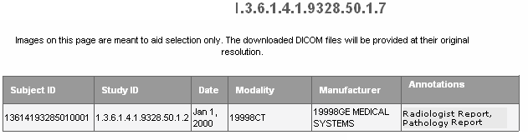

Data Basket Page
The changes made to this page will be the same as changes made to the Search Results (Studies for Subject) page described above.
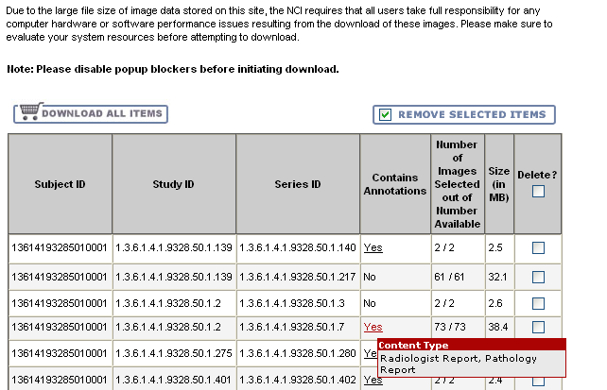

OverlibTag class
The current overlib functionality for help icons is implemented using the HelpTag custom JSP tag. The HelpTag class is specific to help functionality; in particular, the title of the window is always set to “Help” and the link that launches the window cannot be dynamic based on JSF expression language.
A new custom tag named OverlibTag will be created that generically creates an overlib window that will appear when an image or link dynamically generated from JSF expression language is clicked. HelpTag will then be changed to reuse as much of the logic in OverlibTag as possible.

User interface Backing Beans

SeriesDTO
SeriesDTO is an existing class used to hold data in memory for a series. The following new attribute will be added:
New Attribute | Type | Description
ContentTypes | List<String> | A list of strings, each of which is a content type of an annotation file associated with the series.
ContentTypeList | String | There is no setter for this attribute. The getter returns a comma separated list of all content types in the ContentTypes attribute.
HasContentTypes | Boolean | Returns false if ContentTypes is empty.

MIDDLE TIER

SeriesContentTypeResultSet
This new class will inherit from ResultSet and will represent one annotation content type for a series.
It will have the following attributes with getters and setters:
Attribute Name | Type | Description
seriesId | Integer | The primary key of the series
contentType | String | The content type identified by the curator for an annotation file associated with the series

StudiesForSubjectResultSet
This new class will inherit from ResultSet and will represent data returned from DICOMPatientQueryHandler. Because two queries will be executed by DICOMPatientQueryHandler instead of one, this ResultSet class is necessary to hold the results of both queries. It will contain a list of StudyResultSets and a list of SeriesContentTypeResultSet.
It will have the following attributes with getters and setters:
Attribute Name | Type | Description
series | List<StudyResultSet> | List of series
contentTypes | List<SeriesContentTypeResultSet> | List of content types

DICOMPatientQueryHandler
This class currently executes a query that returns one row for each of a patient’s series that matches the original search criteria. A list of series that matched the original criteria is passed in as SeriesIdCriteria.
This query handler will be changed to execute a second query to retrieve the content types for the series. The second query get all CurationData objects where the CdeId matches the contentTypeCdeConceptCode from ncia.properties (see section 4.1) and where the associated series primary key is in the list of series passed to the query handler as SeriesIdCriteria. For each row returned from the second query, a SeriesContentTypeResultSet object will be created.
Instead of returning a list of StudyResultSet objects, a list containing one StudiesForSubjectResultSet object will be returned. Results of the first query will be added as the series attribute of the StudiesForSubjectResultSet and results of the second query will be added as the contentTypes attribute.

ResultSetManager
The getStudies() method of ResultSetManager currently builds a DTO for every StudyResultSet returned from DICOMPatientQueryHandler. Since now a list containing a single StudiesForSubjectResultSet object will be returned, the processing will work differently.
Instead of building the SeriesDTOs directly off of the StudyResultSets returned, ResultSetManager will need to obtain the list of StudyResultSets using the series attribute of StudiesForSubjectResultSet. Then, it will iterate over each SeriesContentTypeResultSet that is stored in the StudiesForSubjectResultSet. It will add each content type to the appropriate SeriesDTO’s contentTypes attribute.

UTILITIES

NCIAConfiguration
Methods will be added to support the new property being added to ncia.properties (see section 4.1).

BACK END

Domain Classes
No changes.

Database Design
No changes.

Views
No changes.

Indexes
No changes.

